SEO Metadata
- Focus Keyword: best web development company in Kolkata
- Meta Title: Best Web Development Company in Kolkata (2026 Guide) | Brewing Ideaz
- Meta Description: Looking for the best web development company in Kolkata? Learn what to evaluate — tech stack, process, scalability, pricing & red flags — before you hire.
- URL Slug: /best-web-development-company-in-kolkata

Secondary Keywords
- web development company in Kolkata
- website development company in Kolkata
- custom web development services in Kolkata
- web application development Kolkata
- ecommerce website development Kolkata
- full stack development company Kolkata
- software development company Kolkata
- CMS website development Kolkata
- responsive website development Kolkata
- Brewing Ideaz Kolkata

Internal Linking Suggestions
- /services/ or /web-development/
- /contact-us/
- /portfolio/ or /case-studies/

Best Web Development Company in Kolkata: A Practical Guide to Choosing the Right Partner
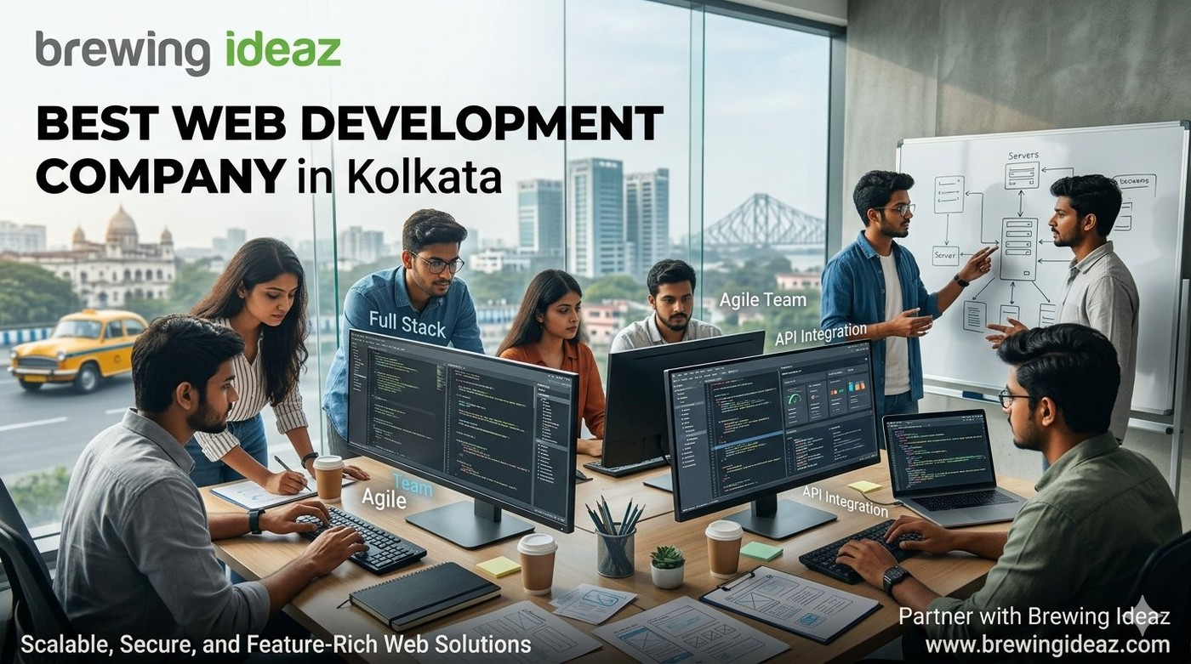
As more Kolkata businesses move online or modernise existing platforms, demand for reliable web development has grown. Many firms claim to be the “best web development company in Kolkata.” Quality of engineering, communication and long-term maintainability differ significantly. This guide helps you evaluate partners with a clear set of criteria.

What “Best” Means in Web Development
A capable web development company builds solutions that are functional, secure, performant and maintainable. Beyond delivering features, strong teams consider architecture, testing, documentation and future change.
Fit matters. A team experienced in simple marketing sites may not be the right choice for a complex web application or high-traffic platform.

Key Factors to Evaluate Before Hiring

Relevant technical experience
Review projects of similar complexity and technology.

Engineering practices
Ask about architecture, code reviews, testing, version control and deployment.

Scalability mindset
Confirm they design with growth and performance in mind.

Team seniority and roles
Understand who designs the architecture and who writes the code.

Communication and transparency
Clear estimates, regular updates and honest handling of issues are essential.

Ownership and support
Ensure source-code ownership, knowledge transfer and defined post-launch support.

Why a Kolkata-Based Development Partner Can Be Advantageous
Local teams share working hours, understand the regional business context, and can offer more accessible collaboration.

Questions to Ask Before You Hire
- Can you describe a recent project of similar scope and the technical choices you made?
- What is your process from requirements to deployment?
- How do you ensure code quality and handle testing?
- Who will be the core team on my project?
- What post-launch support and knowledge transfer do you provide?

Red Flags to Watch For
Avoid companies that cannot discuss technical decisions, offer unusually low prices without clear scope, will not share references or code samples, or push solutions that create unnecessary vendor lock-in.

Final Thoughts
The best web development company in Kolkata for your needs is the one that understands both the technical and business requirements, follows solid engineering practices, and delivers maintainable, ownable code.

Ready to Discuss Your Development Project?
Brewing Ideaz has a branch office in Kolkata (Bangur Avenue) and corporate office in Bengaluru.
Call or WhatsApp: (+91) 62915 47048 Email: info@brewingideaz.com

30 Frequently Asked Questions About Web Development Company in Kolkata
- What is a web development company? A web development company designs, builds, tests and maintains websites and web applications according to a business’s requirements.
- How do I choose the best web development company in Kolkata? Evaluate technical depth, relevant projects, engineering process, team seniority, communication, pricing, and post-launch support.
- What services does a web development company provide? Services typically include custom website development, web applications, e-commerce development, CMS implementation, API integrations, and maintenance.
- How much does web development cost in Kolkata? Cost depends on scope, features, integrations, technology, and timeline. Request a detailed proposal with deliverables and assumptions.
- How long does it take to develop a website? Timelines vary from a few weeks for a marketing site to several months for complex web applications, depending on scope and feedback cycles.
- What is the difference between front-end and back-end development? Front-end development builds what users see and interact with in the browser. Back-end development handles servers, databases, and business logic.
- What is full-stack development? Full-stack development covers both front-end and back-end work, from user interface to server logic and databases.
- What is a CMS and do I need one? A content management system lets non-technical users update website content. It is useful if you plan to publish or edit content regularly.
- Should I choose a custom website or a template-based one? Custom builds offer flexibility and scalability; templates can be faster and cheaper for simple needs. The right choice depends on your goals and budget.
- What technologies do web development companies use? Common choices include HTML, CSS, JavaScript frameworks, Node.js, Python, PHP, and various databases. The stack should fit your requirements.
- What is responsive web development? It ensures a website adapts to different screen sizes and devices so users get a usable experience on mobile, tablet, and desktop.
- Why is website performance important? Faster websites provide a better user experience and can support engagement and conversions.
- What is website security and how is it handled? Security includes secure coding practices, HTTPS, updates, access control, and backups to reduce common risks.
- What is an API integration? An API integration connects your website with other systems such as payment gateways, CRMs, or analytics tools.
- Can a web development company build an e-commerce website? Yes. Many companies build online stores including product catalogues, carts, payments, and order management.
- What is a web application? A web application is interactive software that runs in a browser, such as a dashboard, portal, or booking platform.
- What does a typical web development process look like? Discovery, planning, design, development, testing, deployment, and post-launch support.
- Who owns the source code after the project? Ownership depends on the contract. Confirm source-code ownership, licences, and third-party dependencies in writing.
- What is post-launch support in web development? Support may include bug fixes, updates, monitoring, training, and maintenance under a defined agreement.
- What should I prepare before contacting a web development company? Your goals, target users, required features, reference sites, budget range, and timeline.
- How do I evaluate a web development company’s portfolio? Review live projects for similar complexity, performance, usability, and ask about the technical decisions behind them.
- What are red flags when hiring a web development company? Vague scope, unrealistic timelines, unwillingness to share references, poor communication, and unclear ownership terms.
- What is the difference between web design and web development? Web design focuses on look, layout, and user experience; web development turns designs into a working website or application.
- Can a web development company help with SEO? They can implement technical SEO foundations such as clean structure, speed, and mobile-friendliness. Ongoing SEO may need separate services.
- What is website maintenance? Regular updates, backups, security checks, bug fixes, and content changes to keep a site running well.
- How important is testing in web development? Testing helps identify bugs and usability or performance issues before launch and after changes.
- What is agile development? An iterative approach where work is delivered in short cycles with regular feedback, useful when requirements evolve.
- Why choose a Kolkata-based web development company? A local team may offer convenient communication, overlapping working hours, and familiarity with the regional market.
- Does a web development company guarantee results? No company can reliably guarantee business outcomes; results depend on strategy, market, content, and ongoing effort.
- How can I contact Brewing Ideaz for web development services in Kolkata? Call or WhatsApp +91 62915 47048 or email info@brewingideaz.com to discuss your project.

